**Lilly Biometrics SDTM Annotated CRF Guidelines**

**Revision History**

|  |  |  |
| --- | --- | --- |
| **Version Number** | **Effective Date** | **List of Major Changes** |
| 1.0 | 23October2015 | Initial Release |
| 1.0 | 23October2015 | CORRECTION: Clarified section 2.7 wording |

# Purpose

The intent of this document is to provide guidance to those responsible for the creation of SDTM Annotated CRFs to ensure that the resulting documents conform to industry guidance and are prepared in a consistent manner across the Lilly Biometrics organization.

These SDTM Annotated CRF Guidelines are intended only to address the basic principles for annotating eCRFs, and any mention of additional supporting documentation (such as the define.xml, define.pdf, or Study Data Reviewers Guide (SDRG)) is done for informational purposes only.

This guidance document is divided into two general sections: 1) Pre-Submission SDTM Annotated CRFs and 2) Submission Ready SDTM Annotated CRFs.

**Pre-Submission**: The SDTM Annotated CRF is used to support SDTM programming as well as dataset review.

**Submission Ready**: The SDTM Annotated CRF is provided to assist FDA Reviewers with locating the origin of variables included in the SDTM datasets.

**Table of Contents**

Purpose 1

1.0 Basic Principles for Pre-Submission SDTM Annotated CRFs 3

1.1 General Rules 3

1.2 Appearance of Annotations 2 4

1.3 Domain Names 2 5

1.4 Domain Variables 2 5

1.5 Category Variables (--CAT, --SCAT) 6

1.6 --OBJ: Object of the Observation 7

1.7 Findings Domains 2 7

1.8 Supplemental Qualifier Variables 2 8

1.9 Annotating RELREC Records 2 8

1.10 Annotations to Provide Additional Instruction 2 8

1.11 Data Collection Outside of eCRFs (ePRO, Diary) 9

2.0 Submission Ready SDTM Annotated CRF PDF Requirements 10

2.1 PDF File Version 3 10

2.2 Initial View 10

2.3 Bookmarking 2 10

2.4 Folder Location for Submission 2 11

2.5 Security Settings 3 11

2.6 Page Orientation 3 11

2.7 Page Sizing 3 11

2.8 Page Numbering 3 11

2.9 Document Optimization 3 11

References 11

# 1.0 Basic Principles for Pre-Submission SDTM Annotated CRFs

## General Rules

* + The annotated CRF should be saved as a PDF named **acrf.pdf**1
  + Include and annotate unique forms only. If the entire CRF rather than unique forms will be submitted, then annotate the first occurrence only.

Example: Height, Weight, Blood Pressure, and Pulse are collected at Screening. Blood Pressure and Pulse are collected at subsequent visits except at Discontinuation when Weight, Blood Pressure, and Pulse are collected.

These are considered to be three (3) unique forms and each form should be included and annotated once. If the entire CRF was submitted for this scenario, then the Screening CRF and Discontinuation CRF would be included and annotated. Only the first occurrence of the CRF where just Blood Pressure and Pulse are collected should be included and annotated.

* + The annotated CRF should include treatment assignment forms, when applicable, and should map each variable on the CRF to the corresponding variables in the datasets (or database). The annotated CRF should include the variable names and coding for each CRF item. 1, 2
  + When data are recorded on the CRF, but not planned to be submitted, annotate with the text “NOT SUBMITTED” with brackets placed around the text. For example, data which were used for operational purposes only, such as the question “Did the subject experience any adverse events?” will be annotated [NOT SUBMITTED] and the data will not be included in the datasets. If an ***entire*** CRF page is not submitted, then annotate this once with [NOT SUBMITTED] in the top left corner of the CRF. ***Do not*** annotate each variable on the page.1, 2

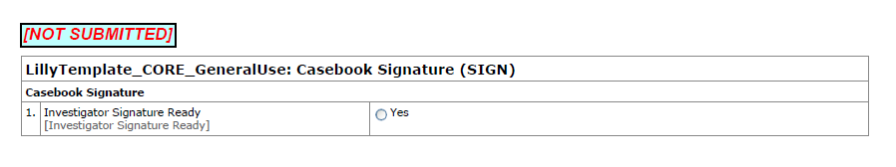

* The annotations should not cover up the CRF text. If necessary use arrows to point from the annotation to the variable location on the CRF.

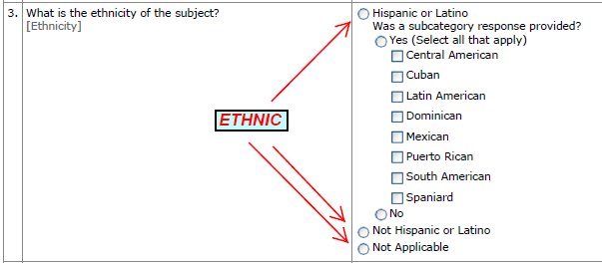

* + Where the equal sign “=” is used as part of the annotation, leave one space prior to and one space after the equal sign.

## Appearance of Annotations 2

Annotation Font Color/Size

* Font Color: Use **Black** for Domains and **Red** for Variables
* Font = Arial, Bold, Italic 3
* Font size(s) may range from 9 to 12 point
* Use 12 point as the default font size for domains
* Use 10 point as the default font size for variable names 3

Annotation Color Coding

* Each domain and all of its variables should be color-coded using the same color scheme.
* If two or more domains exist on a single page then they should use different color schemes (see below).
* It is not necessary to continue the color scheme for a domain across CRF pages. For example, if a CRF page collected data that mapped to both the Medical History (MH) and Concomitant Medications (CM) domain then the MH domain and its variables would be color coded using the Blue fill-in color and the CM domain and its variables would be color coded using the Yellow fill-in color. If another CRF page collected only Concomitant Medications then the CM domain and variable annotations would be color coded using the Blue (not Yellow) fill-in color. The color coding scheme shown below will be reset for each unique CRF page.
* All domain and variable annotations should be outlined in black.

|  |  |  |
| --- | --- | --- |
| **Color Coding Scheme** | **HSL Color Model** | **RGB Color Model** |
| Primary Color = Blue | Hue: 120  Sat: 240  Lum: 210 | Red: 191  Green: 255  Blue: 255 |
| Secondary Color = Yellow | Hue: 40  Sat: 240  Lum: 200 | Red: 255  Green: 255  Blue: 170 |
| Tertiary Color = Green | Hue: 80  Sat: 240  Lum: 210 | Red: 191  Green: 255  Blue: 191 |
| Quaternary Color = Pink | Hue: 230  Sat: 240  Lum: 217 | Red: 255  Green: 206  Blue: 219 |
| Quinary Color = Purple | Hue: 170  Sat: 240  Lum: 216 | Red: 217  Green: 204  Blue: 255 |
| Senary Color = Orange | Hue: 170  Sat: 240  Lum: 200 | Red: 191  Green: 170  Blue: 255 |

## Domain Names 2

* + Each domain that is represented on a CRF page should have its own annotation on the left side of the CRF page with the 2 letter domain code (all caps) and the domain name (mixed case) – e.g. DM = Demographics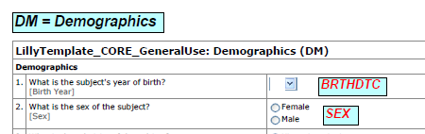
  + SUPPQUAL dataset names do not need to be annotated since SUPPQUAL variables are annotated as part of the main domain. However, if the main domain is not annotated on the CRF then a reference to the main domain should be included in an annotation to provide this additional information.
  + Refer to Section 1.2 Appearance of Annotations for information regarding font, size, and color.

## **Domain Variables 2**

* + Annotate variable names for all collected data fields, including any hidden fields on the CRF page, where applicable.
  + All text which represents variable names must be capitalized.
  + Refer to Section 1.2 Appearance of Annotations for information regarding font, size, and color.

## Category Variables (--CAT, --SCAT)

* + Place the annotations for --CAT and --SCAT at the top of the CRF.
  + If the text of the --CAT variable matches the CRF name, then place the annotation for the --CAT variable next to the CRF name.
  + If the text of the --CAT variable is different from the CRF name, then add an annotation with the –CAT variable name and the text (e.g. DSCAT = PROTOCOL MILESTONE).
  + The same rules are also be applied to the –SCAT variable.

In the example below the CRF Name is **Disposition Event: Lost to Follow Up**. The DSCAT for this form is defined as “Disposition Event” in the Data Element Definition and the DSSCAT is “Study Disposition”. Because the text for DSCAT variable matches the CRF it is only necessary to add an annotation text box with “DSCAT”. However, because the text for the DSSCAT variable is different from what is printed on the CRF, then both the variable name and the text must be included in the annotation. 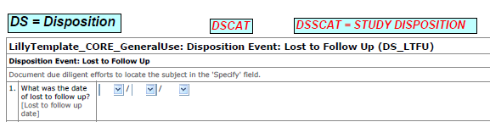

## --OBJ: Object of the Observation

An annotation for the FAOBJ variable should be included for CRFs that are mapped to the Findings About domain.

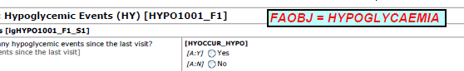

## **Findings Domains 2**

* + Indicate the --TESTCD to which the result or unit applies.

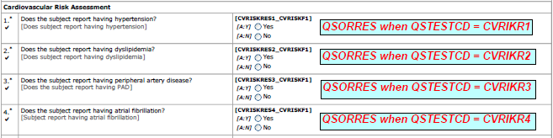

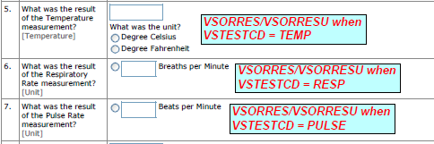

## Supplemental Qualifier Variables 2

* + When annotating SUPPQUAL variables annotate the QNAM value and the SUPPQUAL dataset (e.g. “MHDXDTC in SUPPMH”). Ensure that the SUPPQUAL annotations are color coded using the same color scheme of the corresponding main domain.



## Annotating RELREC Records 2

* + Relationship data collected on CRF pages and documented in RELREC should be annotated.
  + Document the RELREC annotation on the CRF where the variable is being referenced, not on the originating CRF.

In the example below adverse events and medical history events are collected on the Adverse Events CRF and Medical History CRF, respectively. If a subject is taking a medication to treat an AE, the relationship is established by entering the associated AE number on the Concomitant Medication CRF. This relationship is documented on the Concomitant Medication CRF by the annotation “RELREC between CM and AE”. Note that the RELREC annotation should be made on the Concomitant Medication CRF, not on the originating Adverse Event CRF.

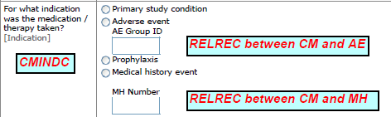

## Annotations to Provide Additional Instruction 2

* + Include additional instructional text in an annotation only as necessary to understand the data and if space permits. If there is insufficient space, then these comments/notes should be included in either the define.xml file or the Study Data Reviewer Guide.

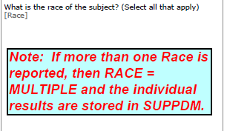

## Data Collection Outside of eCRFs (ePRO, Diary)

For data that are not collected as part of the main CRF for a study (such as with ePRO devices) screenshots or other visualizations should be annotated and appended at the end of the annotated CRF.

# 2.0 Submission Ready SDTM Annotated CRF PDF Requirements

This section only applies to personnel responsible for preparing the acrf.pdf for final data documentation.

## 2.1 PDF File Version 3

PDF versions 1.4 through 1.7, PDF/A-1 and PDF/A-2 are acceptable for documents. Submitted PDF files should be readable by Adobe Acrobat X, should not require additional software or plug-ins to be read and navigate, and should be text searchable. If plug-ins are used during the creation of a PDF document prior to submitting the document, ensure that a plug-in is not needed for review or archive.

PDF files must not contain JavaScript; dynamic content which can include audio, video or special effects and animations; attachments or 3D content. Do not include PDF annotations in documents. Ensure that all hypertext links in documents remain active after conversion to PDF/A.

All annotations must be locked and not editable (i.e. moveable) after finalizing the aCRF.

#### **2.2 Initial View** 3

Set the Navigation Tab to open to “Bookmarks Panel and Page.” This sets the initial document view when the file is opened.

All bookmark sections should be collapsed to the lowest level of the bookmark hierarchy as the default setting when opening the annotated CRF.

All bookmarks and hyperlinks must be set to Magnification=Inherit-Zoom.

All bookmarks must have a page set for the PAGE DESTINATION.

## 2.3 Bookmarking 2

Annotated CRFs included in the eCTD should be bookmarked two ways (dual bookmarking): bookmarks by timepoints, often analogous to planned visits in the study, and bookmarks by CRF topics or forms.

Bookmarks by timepoints should be ordered chronologically according to the study Time and Events schedule (T&E) with the study level bookmarks (AE) presented last. Within each timepoint, topic bookmarks should appear in the order that they appear in the annotated CRF.

Bookmarks by topics should be ordered alphabetically. Within each topic all applicable timepoints should be ordered chronologically according to the T&E schedule.

## 2.4 Folder Location for Submission 2

The bookmarked and annotated CRF from the study should be saved in a PDF named acrf.pdf and stored in the “sdtm” folder. All unique CRF pages or forms should be annotated to match the SDTM datasets and variables.

## 2.5 Security Settings 3

Do not activate security settings or password protection. The integrity of the submitted files is maintained through Agency security and archival process.

## 2.6 Page Orientation 3

Save the page orientation for proper viewing and printing within the document. Proper page orientation eliminates the need for reviewers to rotate pages. For example, setting the page orientation of landscape pages to landscape prior to saving the PDF document in the final form ensures a correct page presentation.

## 2.7 Page Sizing 3

Page size and margins should conform to the guidance described in the Portable Document Format (PDF) Specifications: Technical Specifications Document.

## 2.8 Page Numbering 3

In general, it is easier to navigate through an electronic document if the page numbers for the document and the PDF file are the same, with the initial page of the document numbered as page one. There is an exception when a document is split because of its size (e.g., > 400 MB) and the second or subsequent file is numbered consecutively to that of the first or preceding file.

## 2.9 Document Optimization 3

Create files from source documents using the “Optmize the PDF for fast web view” option to reduce file sizes and file opening times.

# References

|  |
| --- |
| 1 Study Data Technical Conformance Guide (June 2015) |
| 2 Study Data Tabulation Model Metadata Submission Guidelines (SDTM-MSG) (12-31-2011) |
| 3 Portable Document Format Specifications (PDF) (Sept 2014) also named (UCM163565) |